***PAAREES PERFUMES***

***Christian Diors***

***FOR MEN***

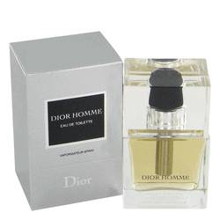

# *Dior Homme*

***Description:***

Dior Homme by Christian Dior Cologne. Christian Dior presented Dior Homme in 2005 for the man in search of a traditional scent to wear on any occasion. Its appealing fragrance encompasses the cool and refreshing top notes of sage and bergamot and eventually brings out faint floral traces of powdery lavender and iris. As these heart notes linger, the amber base notes take center stage to complete this complex blend of scents unlike any other in a captivating fragrance known as Dior Homme.